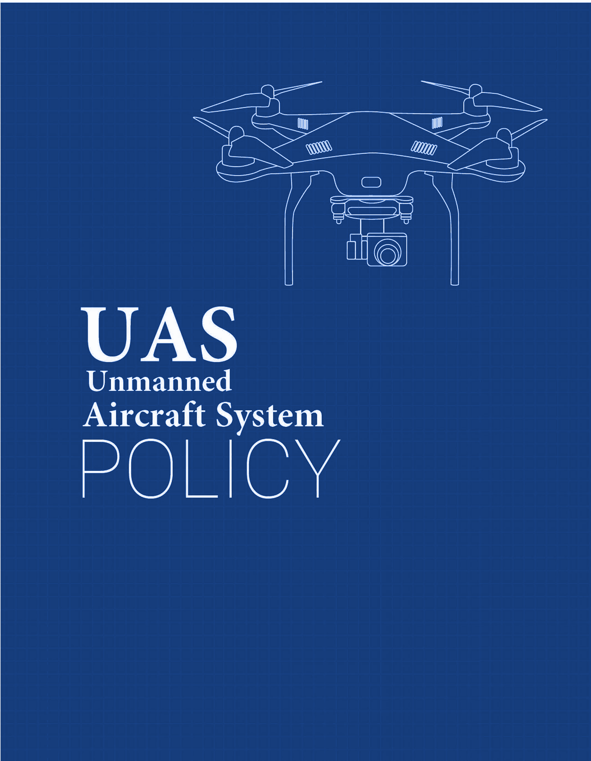

Venue Name

[Venue Name] UAS Policy

Table of Contents

**Policy** **3**

Purpose 3

Authority 3

Scope 3

**Definitions** **4**

**Operating Procedures** **5**

Procedure for Flight approval 5

Classification of Use 5

UAS Registration Requirement 6

Commercial Operation 6

Payload Authorization 6

Prohibited UAS Use 6

**Part 107** **7**

Standard Operating Rules 7

Operating Limitations - Waivers 8

Outside Contractors 8

**Pre-Flight/Post-Flight** **9**

**Sanctions** **12**

**Resources** **12**

**Frequently Asked Questions** **12**

## 

## Policy

### Purpose

The purpose of this Unmanned Aircraft System (UAS) Policy is to establish scope and governance of Unmanned Aircraft Systems (UAS) activities for [Venue Name] and the use of UAS on or over business property. It also serves to establish the Designated UAS Authority responsible for overseeing UAS activities at [Venue Name].

This policy requires that all [Venue Name] sponsored UAS operations taking place on-site or off-site, will be conducted in a manner ensuring individual privacy and safety, in accordance with all applicable Federal, State, and Local laws.

### Authority

[Designated UAS Authority] is responsible for approving any UAS on [Venue Name] property or at any Venue sponsored activity or event.

Contacts:

Department_______________

UAS Coordinator_______________

Phone number_______________

Email_______________

### Scope

This policy is applicable to:

* + 1. Venue employees, staff, and third-party operators operating UAS in any location for business activities.
    2. All platforms of UAS which include, but are not limited to: sUAS, UAV, Drone, Model Aircraft, regardless of size or weight.
    3. Any individuals who operate UAS on [Venue Name] property, including persons not affiliated with the company.
    4. Any individuals operating UAS purchased with funding through the

company.

## Definitions

**Federal Aviation Administration (FAA)** – A division of the Department of Transportation that inspects and rates civilian aircraft and pilots, enforces the rules of air safety, and installs and maintains air-navigation and traffic-control facilities.

**Unmanned Aircraft System (UAS)** – An unmanned aircraft system, sometimes called a drone, is an aircraft without a human pilot onboard – instead, the drone is controlled from an operator on the ground. Sometimes prefaced as a Small Unmanned Aircraft System (sUAS).

**Unmanned Aerial Vehicle (UAV)** - An unmanned aerial vehicle is a powered, aerial vehicle that does not carry a human operator, uses aerodynamic forces to provide vehicle lift, can fly autonomously or be piloted remotely.

**Drone** - The common term for UAV, UAS, and sUAS.

**Remote Pilot-in-Command (RPIC)** - The official term given by the FAA for the individual who either directly operates the UAS or directly supervises another individual operating the UAS. The Remote Pilot in Command must have the proper FAA UAS pilot certifications and abide by the necessary FAA regulations and this policy.

**Designated UAS Authority** – The individual, department, or committee designated by the [Venue Name] as authorized to provide oversight for UAS activities.

## Operating Procedures

### Procedure for Flight approval

Regardless of flight purpose, anyone intending to fly a UAS at [Venue Name] or sponsored activity/event must submit an application to [the Company’s] [UAS Authority] department.

Application must include:

* Photo ID
* Proof of FAA registration
* Picture of UAV with owner information included
* Screenshot from FAA website that shows flight path is not in the “no-fly zone”
* If this is a no-fly zone, FAA permit is required
* Copy of Part 107 licenses (Commercial use only)
* Copy of vendor insurance (Commercial use only)
* Safety plan (Commercial use only)

Application review: [Designated UAS Authority] will review the application, request additional information to either approve or deny. [Designated UAS Authority] reserves the right to cancel or reschedule any approved UAS usage.

Approval: Upon approval, the applicant will be issued a UAS use permit, authorizing the use of UAS as outlined in the permit. The pilot must keep a physical copy of the UAS permit on him/her while operating the UAS. The [UAS Authority] will approve only the necessary duration for the proposed activity. Recurring flight approvals may be requested.

### Classification of Use

* Business Operation: In-house business operations of a UAS is permitted on venue property. It will require approval from the [Venue Name] UAS department.
* Outside Contractor Operation: Commercial UAS operations and 3rd party vendors are permitted after application approval from [Department Name] department.

### UAS Registration Requirement

* UAS that weigh in excess of 0.55 Lbs. must be registered with the FAA before an application if submitted. Proof of registration must be submitted with the application.
* UAS registration number and owner contact information must be listed on the UAV
* Non-US Citizens who are not eligible to register a UAS in the united states must follow the FAA guidelines.

### Commercial Operation

* All Commercial UAS operations must be conducted by a certified remote Pilot with a (Part 107).
* Third-party/Commercial operators must provide a copy of their insurance coverage when submitting the application.
* The venue must also check the FAA guidelines and zones before flying and obtain a proper exemption if the flight-area is located in a no fly zone.

### Payload Authorization

The person requesting authorization to operate a UAS must identify the payload function, size, and weight. Access points or any devices that might interfere with venue networks are prohibited.

### Prohibited UAS Use

UAS operation is prohibited if any person(s) acting as a UAS pilot:

* Consumed alcohol in the past 12 hours
* Have used any drugs that affect the person’s faculties in any way
* Operated without a permit
* For recreational use

## Part 107

### Standard Operating Rules

1. The remote pilot in command must conduct a pre-flight inspection. The remote pilot should record the pre-flight inspection via hard copy document or appropriate web-based application.
2. The remote pilot may not go forward with the operation if he or she believes that there are any physical or mental conditions, drug- or alcohol-induced or otherwise, that would interfere with the safe operation of the UAS.
3. The remote pilot must maintain visual line-of-sight at all times.
4. Where possible, a visual observer should assist in operations.
5. No operations over people unless those people are directly participating in the operation.
6. Operations within daylight hours only. [COMPANY] UASs may operate during twilight hours (30 minutes before official sunrise to 30 minutes after official sunset) if the UAS has anti-collision lighting.
7. UASs must always yield the right-of-way to other aircraft.
8. Maximum ground speed of 100 mph (87 knots).
9. Maximum altitude of 400 feet above ground level. i. A UAS may go above 400 feet if it remains within 400 feet of a structure.
10. Operations must stay within Class G airspace – well away from airports. However, should the pilot in command determine that to perform [COMPANY] duties operations may move into Class B, C, D or within the lateral boundaries of the surface area of Class E airspace, the remote pilot must request and receive permission from the appropriate Air Traffic Controller. Please see Appendix 1 for further information.
11. Operations should also, where practicable, stay at least one mile away from heliports, including hospitals with heliports.
12. UASs may only fly when visibility is at least at 3 miles.
13. No operations from a moving aircraft.
14. No operations from a moving vehicle unless the operation is over a sparsely populated area.
15. No careless or reckless operations (e.g., no stunt flying).
16. No carriage of hazardous materials.
17. In the event of operations that lead to serious injury, loss of consciousness, or property damage of at least $500, it is the remote pilot’s responsibility to make an official report to the FAA. This can be done in coordination with designated [COMPANY] supervisors or personnel.

### Operating Limitations - Waivers

1. All remote pilots must make sure UAV operation falls within the standard FAA Part 107 operating rules.
2. If it becomes clear that compliance with a certain or multiple of Part 107’s limitations is not practical to get the full benefit of [COMPANY’s] UAV usage, the remote pilot or responsible individual should bring such to the attention of the UAS coordinator or other assigned supervisor.
3. [COMPANY] will then make an application to the FAA for a waiver for the specific Part 107 limitation.
4. Waivers are available for:

* Operation from a moving vehicle or aircraft (§ 107.25)*
* Daylight operation (§ 107.29)
* Visual line of sight aircraft operation (§ 107.31)*
* Visual observer (§ 107.33)
* Operation of multiple small unmanned aircraft systems (§ 107.35)
* Yielding the right of way (§ 107.37(a))
* Operation over people (§ 107.39)
* Operation in certain airspace (§ 107.41)
* Operating limitations for small unmanned aircraft (§ 107.51)

### Outside Contractors

1. The [COMPANY] UAS coordinator is responsible for coordinating the work of contractors who will be utilizing UASs on [COMPANY’s] behalf is responsible for providing that contractor with a copy of this policy.
2. The contractor must agree to abide by the FAA Part 107 regulations – or the contractor’s Section 333 Exemption – and related policy points within this document.
3. The contractor must agree, as a part of its contract, to indemnify and hold [COMPANY] harmless from any liability stemming from personal injury or property damage arising from the contractor’s UAS operations.
4. The contractor must further agree to procure adequate insurance of $____ million to protect against such liability, and provide [COMPANY] with a certificate of insurance showing [COMPANY’s] additional insured status.

## Pre-Flight/Post-Flight

Pre-Flight Checklists and Mission Logs must be conducted for each UAS mission by the [Venue Name] or by a third-party for the [Venue Name]. If more than one drone is flown during the same mission, each drone and its flight details must recorded on the Mission Log report. Below are examples of a Pre-Flight Checklist and a UAS Flight Mission Log.

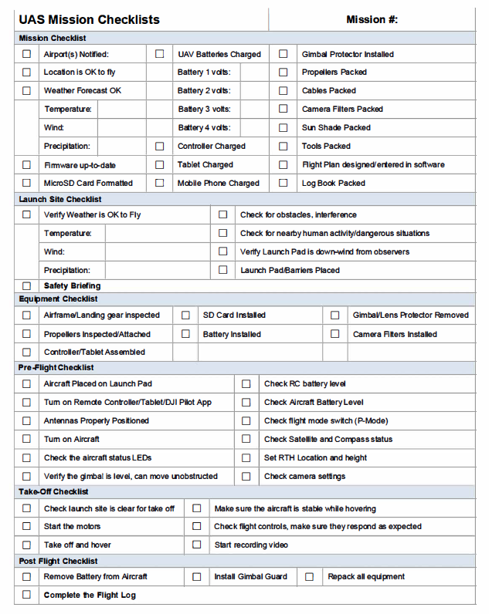

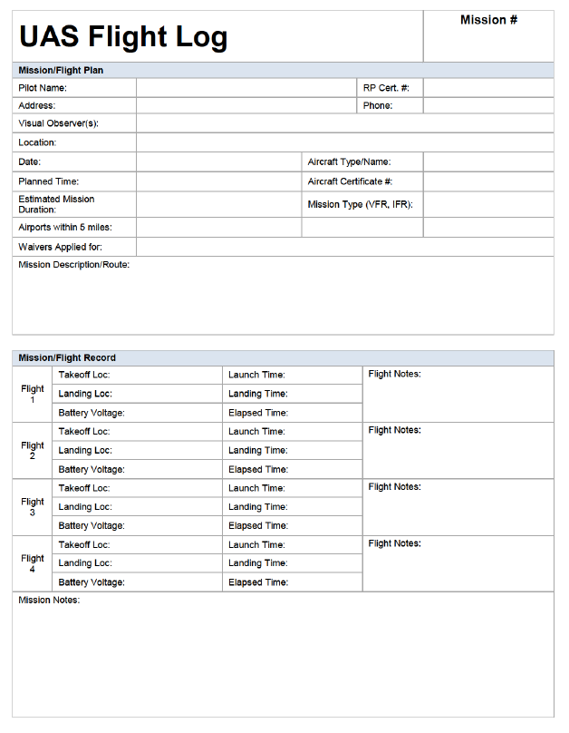

## Sanctions

Any violations of venue policies by an individual will be dealt with in accordance with applicable venue policies and procedures, which may include disciplinary actions.

Fines or damages incurred by individuals or units that do not comply with this policy will not be paid by [Venue Name] and will be the responsibility of those persons involved.

## Resources

FAA’s general page for Unmanned Aircraft Systems information: <https://www.faa.gov/uas/>

FAA B4UFly Mobile App

<https://www.faa.gov/uas/where_to_fly/b4ufly/>

FAA Summary of Small Unmanned Aircraft Rule (Part 107): <https://www.faa.gov/uas/media/Part_107_Summary.pdf>

FAA’s Becoming a Pilot:

<https://www.faa.gov/uas/getting_started/part_107/remote_pilot_cert/>

FAA’s Sample Preflight Inspection Checklist: [https://www.faasafety.gov/files/gslac/courses/content/451/1458/Preflight%20Inspection%20 Checklist.pdf](https://www.faasafety.gov/files/gslac/courses/content/451/1458/Preflight%20Inspection%20)

U.S. DHS Best Practices for Protecting Privacy, Civil Rights & Civil Liberties In UAS Programs:

<https://www.dhs.gov/sites/default/files/publications/UAS%20Best%20Practices.pdf>

## Frequently Asked Questions

You may want to consider answering some Frequently Asked Questions, to help inform and educate your employees and any third-party operators on the use of drones on or near your business.

FAA Frequently Asked Questions: <https://www.faa.gov/uas/faqs/>

Sample questions:

* Are employees allowed to fly drones on [Venue Name] property?
* Do I need permission to fly drones on [Venue Name] property?
* How do I get permission to fly drones on [Venue Name] property?
* Who do [Venue Name]’s drone policy and flight operations manual apply to?
* Do I need to register my UAS?
* Do I need to notify [Venue Name] each time I fly my drone?
* What do I need to do if I crash my drone?
* What do I do if I think someone is violating the venue drone policy?
* What restrictions on filming video with drones on business property are there?
* Can news media fly a UAS over [Venue Name] to photograph/video stories or cover breaking news?

Created by:



**Solutions to Secure Your Airspace**

[**www.911security.com**](http://www.911security.com/)