Table of Contents

**Policy** **3**

Purpose 3

Authority 3

Scope 3

**Definitions** **4**

**Operating Procedures** **4**

Authorization of UAS deployment 4

Certification and Training 5

Permissible UAS Use 5

UAS Registration Requirement 6

Commercial Operation 6

Payload Authorization 6

Prohibited UAS Use 6

**Pre-Flight/Post-Flight** **7**

**Data Retention and Reporting** **10**

COA Reporting Requirements: 10

**Sanctions** **11**

**Resources** **11**

**Frequently Asked Questions** **11**

## 

## Policy

### Purpose

The purpose of this Unmanned Aircraft System (UAS) Policy is to establish scope and governance of Unmanned Aircraft Systems (UAS) use for [Department Name]. It also serves to establish the UAS Authority Committee responsible for overseeing UAS activities and missions.

As with all missions of the [Department Name], UAS activities will be conducted in a manner ensuring individual privacy and safety, in accordance with all applicable Federal, State, and Local laws.

### Authority

UAS Committee Team is responsible for supervising any UAS activities or missions for the [Department Name].

Contacts:

Department_______________

UAS Program Coordinator_______________

Phone number_______________

Email_______________

The UAS will be operated within the current guidelines of the FAA, [Department Name], and any existing Certificate of Waiver or Authorization (COA) conditions. Only authorized operators who have been designated by the UAS Program Coordinator shall be permitted to operate the UAS, and only under the direct supervision of a remote pilot-in-command (RPIC), if they are not certified.

### Scope

This policy is applicable to:

* + 1. Department Name employees and third-party operators operating UAS for any type of official Department business.
    2. All platforms of UAS which include, but are not limited to: sUAS, UAV, Drone, Model Aircraft, regardless of size or weight.
    3. Any individuals operating UAS purchased with funding through the

[Department Name].

## Definitions

**Federal Aviation Administration (FAA)** – A division of the Department of Transportation that inspects and rates civilian aircraft and pilots, enforces the rules of air safety, and installs and maintains air-navigation and traffic-control facilities.

**Unmanned Aircraft System (UAS)** – An unmanned aircraft system, sometimes called a drone, is an aircraft without a human pilot onboard – instead, the drone is controlled from an operator on the ground. Sometimes prefaced as a Small Unmanned Aircraft System (sUAS).

**Unmanned Aerial Vehicle (UAV)** - An unmanned aerial vehicle is a powered, aerial vehicle that does not carry a human operator, uses aerodynamic forces to provide vehicle lift, can fly autonomously or be piloted remotely.

**Drone** - The common term for UAV, UAS, and sUAS.

**Remote Pilot-in-Command (RPIC)** - The official term given by the FAA for the individual who either directly operates the UAS or directly supervises another individual operating the UAS. The Remote Pilot in Command must have the proper FAA UAS pilot certifications and abide by the necessary FAA regulations and this policy.

**UAS Authority Committee** – The individual, team, or department designated by the [Department Name] as authorized to provide oversight for UAS activities.

## Operating Procedures

### Authorization of UAS deployment

Regardless of flight purpose, anyone intending to fly a UAS for official [Department Name] business must submit an application to the UAS Committee.

Application must include:

* Photo ID
* Proof of FAA registration
* Picture of UAV with owner information included
* If this is a no-fly zone, FAA permit is required
* Copy of Part 107 licenses (Commercial use only)
* Copy of vendor insurance (Commercial use only)
* Safety plan (Commercial use only)

Authorization review: [UAS Committee] will review the application, request additional information to either approve or deny. [UAS Committee] reserves the right to cancel or reschedule any approved UAS usage.

Approval: Upon approval, the applicant will be issued a UAS use permit, authorizing the use of UAS as outlined in the application. The pilot must keep a physical copy of the UAS permit.

### Certification and Training

* No public safety agency shall acquire or operate a UAV without having first obtained the necessary Certificate(s) of Authorization or waivers from the FAA.
* UAVS shall be operated only by personnel who have received appropriate training regarding the UAV being utilized, training in the policies and procedures of the agency and general training in the controlling legal principles dealing with search, seizure and privacy.

### Permissible UAS Use

* Search and Rescue Operations
* Accident and Crime Scene Investigations
* Disaster Management
* Security
* Active Pursuit Support
* Support and Coordination with Fire/ EMS and Other Government Agencies
* Use of vision enhancement technology (e.g., thermal and other imaging equipment) is permissible in viewing areas only where there is no protectable privacy interest, or when in compliance with a search warrant or court order, or in an emergency. In all other instances, legal counsel should be consulted.

### UAS Registration Requirement

* UAS that weight in excess of 0.55 Lbs. must be registered with the FAA before an application if submitted. Proof of registration must be submitted with the application.
* UAS registration number and owner contact information must be listed on the UAV
* Non-US Citizens who are not eligible to register a UAS in the united states must follow the FAA guidelines.

### Commercial Operation

* All Commercial UAS operations must be conducted by a certified remote Pilot with a (Part 107).
* The company must also provide a copy of their insurance coverage when submitting the application.
* The company must also check the FAA guidelines and zones before flying and obtain a proper exemption if the university is located in a no fly zone.

### Payload Authorization

The person requesting authorization to operate a UAS, must clearly identify the payload function, size and weight.

### Prohibited UAS Use

UAS operation is prohibited if any person(s) acting as a UAS pilot:

* Consumed alcohol in the past 12 hours.
* Have used any drugs that affect the person’s faculties in any way.
* Operated without proper training

UAS video surveillance equipment shall not be used:

* To conduct random surveillance activities.
* To target a person based solely on individual characteristics, such as, but not limited to race, ethnicity, national origin, religion, disability, gender or sexual orientation.
* To harass, intimidate or discriminate against any individual or group.
* To conduct personal business of any type.

## Pre-Flight/Post-Flight

Pre-Flight Checklists and Mission Logs must be conducted for each UAS mission by the [Department Name] or by a third-party for the [Department Name]. If more than one drone is flown during the mission, each drone flight must be logged on the Mission Log report. Listed below is a sample flight checklist and mission log that your department can use.

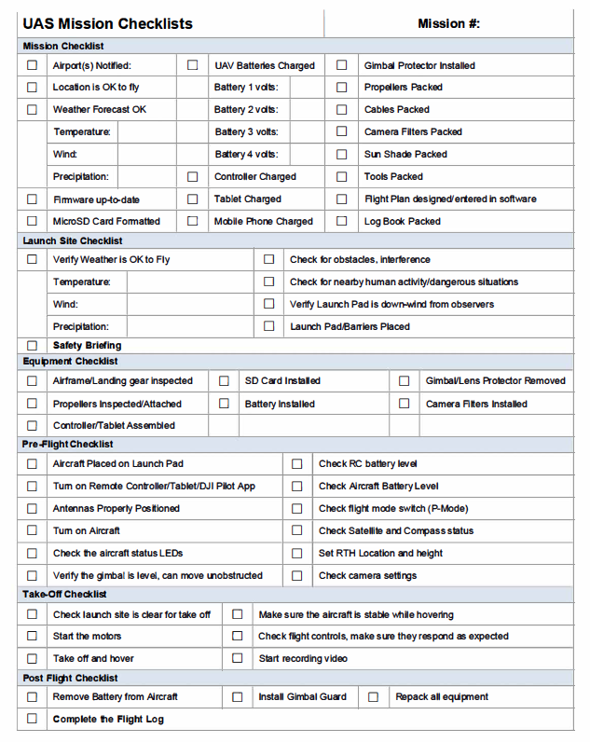

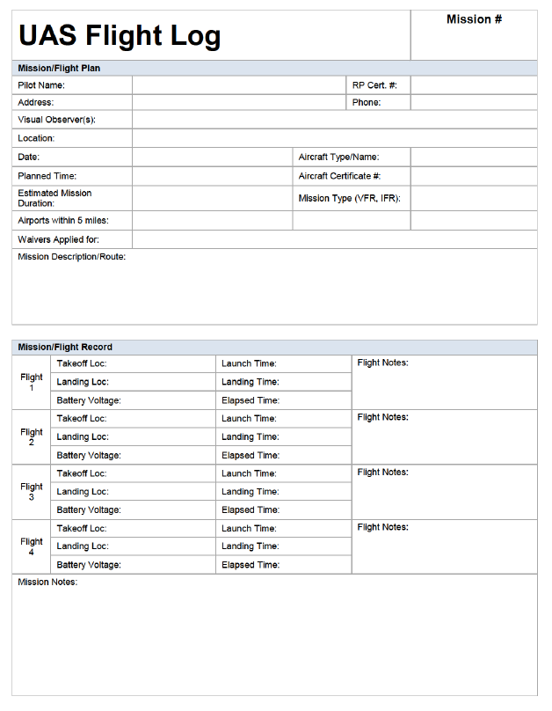

## Data Retention and Reporting

The [Department Name] will follow FAA rules and state laws applicable to data retention and reporting. Photographs and video collected by the UAS shall be retained in accordance with [Your State] State Records Retention Schedules.

Agency reporting of UAS Mission Logs will depend on whether your department operates UAS with a COA or part 107. Part 107 does not require monthly reports unless you have a separate waiver that may require reporting.

### COA Reporting Requirements:

1. Documentation of all operations associated with UAS activities is required regardless of the airspace in which the UAS operates. NOTE: Negative (zero flights) reports are required. This means you have to report your monthly activity even if you did NOT fly.
2. The operator must submit the following information through mailto: 9-AJV-115-UASOrganization@faa.gov on a monthly basis:

a. Name of Operator, Exemption number and Aircraft registration number

b. UAS type and model.

c. All operating locations, to include location city/name and latitude/longitude

d. Number of flights (per location, per aircraft)

e. Total aircraft operational hours

f. Takeoff or Landing damage

g. Equipment malfunctions. Reportable malfunctions include, but are not limited to the following:

* On-board flight control system
* Navigation system
* Fuel system failure
* Electrical system failure
* Control station failure

1. The number and duration of lost link events (control, performance and health monitoring, or communications) per UAS per flight.

## Sanctions

In cases of infractions, it’s the responsibility of each member to make immediate corrections if possible and to report all infractions to the UAS program coordinator. The UAS program coordinator will ensure corrective actions are taken at the earliest possible time, net results are documented, and appropriate parties are respectively notified.

## Resources

FAA’s general page for Unmanned Aircraft Systems information: <https://www.faa.gov/uas/>

FAA B4UFly Mobile App

<https://www.faa.gov/uas/where_to_fly/b4ufly/>

FAA Certificate of Waiver or Authorization (COA)

<https://www.faa.gov/about/office_org/headquarters_offices/ato/service_units/systemops/aaim/organizations/uas/coa/>

FAA Summary of Small Unmanned Aircraft Rule (Part 107): <https://www.faa.gov/uas/media/Part_107_Summary.pdf>

FAA’s Becoming a Pilot:

<https://www.faa.gov/uas/getting_started/part_107/remote_pilot_cert/>

FAA’s Sample Preflight Inspection Checklist: [https://www.faasafety.gov/files/gslac/courses/content/451/1458/Preflight%20Inspection%20 Checklist.pdf](https://www.faasafety.gov/files/gslac/courses/content/451/1458/Preflight%20Inspection%20)

Know Before You Fly

<http://knowbeforeyoufly.org/>

U.S. DHS Best Practices for Protecting Privacy, Civil Rights & Civil Liberties In UAS Programs:

<https://www.dhs.gov/sites/default/files/publications/UAS%20Best%20Practices.pdf>

## Frequently Asked Questions

You may want to consider answering some Frequently Asked Questions, to help inform and educate your public civilians, employees, and any third-party operators on the use of drones in your community.

FAA Frequently Asked Questions: <https://www.faa.gov/uas/faqs/>

Created by:



**Solutions to Secure Your Airspace**

[**www.911security.com**](http://www.911security.com/)