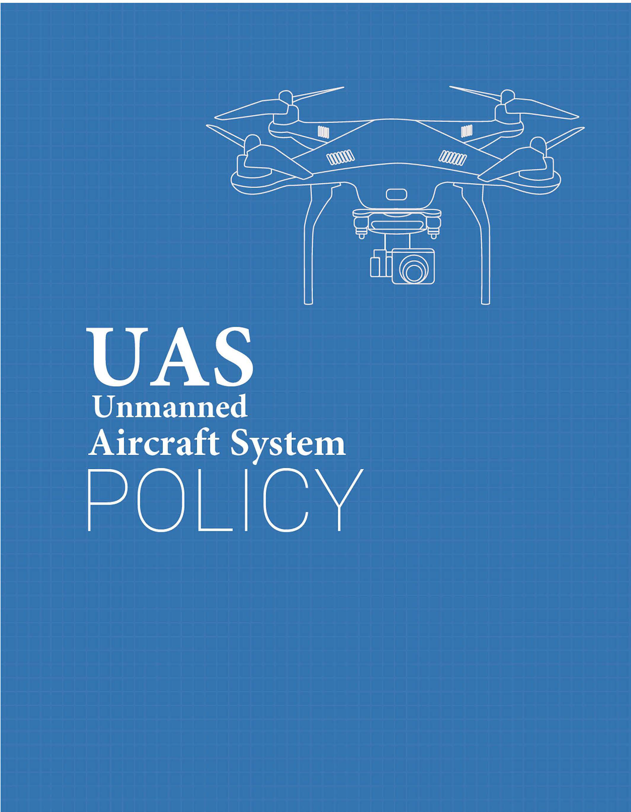

University Name

[University Name] UAS Policy

Table of Contents

**Policy**3

Purpose 3

Authority 3

Scope 3

**Definitions**4

**Operating Procedures**5

Procedure for Flight approval 5

Classification of Use 5

UAS Registration Requirement 6

Recreational UAS Operation 6

Commercial UAS Operation 6

UAS Operating Guidelines 6

Prohibited UAS Use 7

Payload Authorization 7

**Pre-Flight/Post-Flight**7

**Sanctions**8

**Accidents & Reporting**9

**Resources**9

**Frequently Asked Questions**9

## 

## Policy

### Purpose

The purpose of this Unmanned Aircraft System (UAS) Policy is to establish scope and governance of Unmanned Aircraft Systems (UAS) activities for [University Name] business and the use of UAS on or over University property. It also serves to establish the Designated UAS Authority responsible for overseeing UAS activities at [University Name].

This policy requires that all [University Name] sponsored UAS operations taking place on-campus or off-campus, will be conducted in a manner ensuring individual privacy and safety, in accordance with all applicable Federal, State, and Local laws.

### Authority

[Designated UAS Authority] is responsible for approving any UAS on [University Name] campus or at any University sponsored activity or event.

Contacts:

Department_______________

Phone number_______________

Email_______________

### Scope

This policy is applicable to:

* + 1. University faculty, staff, and students operating UAS in any location as part of their University research, teaching, student organization, employment activities, or recreational uses.
    2. All platforms of UAS which include, but are not limited to: sUAS, UAV, Drone, Model Aircraft, regardless of size or weight.
    3. Any individuals who operate UAS on [University Name] property, including persons not affiliated with the University.
    4. Any individuals operating UAS purchased with funding through the

University, including University accounts, grants, or foundation accounts.

## Definitions

**Federal Aviation Administration (FAA)** – A division of the Department of Transportation that inspects and rates civilian aircraft and pilots, enforces the rules of air safety, and installs and maintains air-navigation and traffic-control facilities.

**Unmanned Aircraft System (UAS)** – An unmanned aircraft system, sometimes called a drone, is an aircraft without a human pilot onboard – instead, the drone is controlled from an operator on the ground. Sometimes prefaced as a Small Unmanned Aircraft System (sUAS).

**Unmanned Aerial Vehicle (UAV)** - An unmanned aerial vehicle is a powered, aerial vehicle that does not carry a human operator, uses aerodynamic forces to provide vehicle lift, can fly autonomously or be piloted remotely.

**Drone** - The common term for UAV, UAS, and sUAS.

**Remote Pilot-in-Command (RPIC)** - The official term given by the FAA for the individual who either directly operates the UAS or directly supervises another individual operating the UAS. The Remote Pilot in Command must have the proper FAA UAS pilot certifications and abide by the necessary FAA regulations and this policy.

**Designated UAS Authority** – The individual, department, or committee designated by the [University Name] as authorized to provide oversight for UAS activities.

**Designated UAS Area** - An area on campus with specific boundaries that the University has approved for recreational and/or educational drone use.

**University Business** – The term “University Business” means the official activities of a University that contribute to any one of the University’s major functions of teaching, research, patient care, or public service, or to any other non-recreational University purpose.

## Operating Procedures

### Procedure for Flight approval

Regardless of flight purpose, anyone intending to fly a UAS at [University Name] campus or sponsored activity/event must submit an application to the [Designated UAS Authority].

Application must include:

* Photo ID
* Proof of FAA registration
* Picture of UAV with owner information included
* Screenshot from FAA website that shows that this is not a no-fly zone
* If this is a no-fly zone, FAA permit is required
* Copy of Part 107 licenses (Commercial use only)
* Copy of vendor insurance (Commercial use only)
* Safety plan (Commercial use only)

Application review: [Designated UAS Authority] will review the application, request additional information to either approve or deny. [Designated UAS Authority] reserves the right to cancel or reschedule any approved UAS usage.

Approval: Upon approval, the applicant will be issued a UAS use permit, authorizing the use of UAS as outlined in the permit. The pilot must keep a physical copy of the UAS use permit and a University ID. The University will approve only the necessary duration for the proposed activity. Recurring flight approvals may be requested.

### Classification of Use

* Recreation UAS Operation: Personal recreational operation of a UAS is permitted in designated areas on campus. Students and faculty do not need permission for each flight. The [Designated UAS Authority] should predetermine the length of time a permit will be valid. The [Designated UAS Authority] may choose to validate permits by semester or school year.
* Educational UAS Operation: The Educational use of a UAS is permitted. It will require approval from the [Designated UAS Authority].
* Commercial UAS Operation: Commercial UAS operations and 3rd party vendors are permitted after application approval from [Designated UAS Authority].

### UAS Registration Requirement

* UAS that weigh more than 0.55 lbs must be registered with the FAA before an application is submitted. Proof of registration must be submitted with the application.
* UAS registration number and owner contact information must be displayed on the UAV.
* Non-US Citizens who are not eligible to register a UAS in the united states must follow the FAA guidelines.

### Recreational UAS Operation

* Students and faculty may operate UAS in the [Designated UAS Area] with approval from the [Designated UAS Authority].
* Students and faculty must adhere to the guidelines in this policy and obey any state and federal laws while operating UAS.

### Commercial UAS Operation

* All Commercial UAS operations must be conducted by a certified remote Pilot with a Part 107 license.
* The company must also provide a copy of their insurance coverage when submitting the application.
* The company must also check the FAA guidelines and zones before flying and obtain a proper exemption if the university is located in a no-fly zone.

### UAS Operating Guidelines

Regardless of use, anyone operating a UAS must adhere to the following:

* UAS must be flown under 400 feet
* UAS must be flown during daylight hours (official sunrise to sunset)
* UAS operator must maintain line of sight with drone
* UAS operator must respect the privacy of others
* UAS must not be flown in a manner that violates Section III (G)

### Prohibited UAS Use

UAS pilot operating a drone should:

* Never fly over roads, groups of students, public events, or stadiums full of people
* Note: if your University stadium seats 30,000 or greater, under FAA rules no one is allowed to fly a drone within a three-mile radius of the stadium one hour prior to football game time until one hour after the football game ends
* Never fly near other aircraft or near airports
* Never fly near emergencies such as fires or hurricane recovery efforts
* Never fly under the influence of drugs or alcohol

### Payload Authorization

The person requesting authorization to operate a UAS, must clearly identify the payload function, size and weight. Access points or any devices that might interfere with the campus network are prohibited.

## Pre-Flight/Post-Flight

Pre-Flight Checklists and Mission Logs must be conducted for each UAS mission by the [University Name] or by a third-party for the [University Name]. If more than one drone is flown during the mission, each drone and its flight must be logged on the Mission Log report.

Pre-Flight Checklist:

* Visually inspect the condition of the unmanned aircraft system components
* Inspect the airframe structure, including undercarriage, all flight control surfaces and linkages
* Inspect registration markings for proper display and legibility
* Inspect movable control surface(s), including airframe attachment point(s)
* Inspect servo motor(s), including attachment point(s)
* Inspect the propulsion system, including powerplant(s), propeller(s), rotor(s), ducted fan(s), etc.
* Verify all systems (e.g. aircraft, control unit) have an adequate energy supply for the intended operation and are functioning properly
* Inspect the avionics, including control link transceiver, communication/navigation equipment and antenna(s)
* Calibrate UAS compass prior to any flight
* Inspect the control link transceiver, communication/navigation data link transceiver, and antenna(s) Check that the display panel, if used, is functioning properly
* Check ground support equipment, including takeoff and landing systems, for proper operation
* Check that control link correct functionality is established between the aircraft and the control station Check for correct movement of control surfaces using the control station
* Check on board navigation and communication data links
* Check flight termination system, if installed
* Check fuel for correct type and quantity
* Check battery levels for the aircraft and control station
* Check that any equipment, such as a camera, is securely attached
* Verify communication with UAS and that the UAS has acquired GPS location from at least 4 satellites Start the UAS propellers to inspect for any imbalance or irregular operation
* Verify all controller operation for heading and altitude
* If required by flight path walk through, verify any noted obstructions that may interfere with the UAS
* At a controlled low altitude, fly within range of any interference and recheck all controls and stability

Post-flight record data should include:

* Date
* Pilot
* Aircraft
* Location/Flight Path
* Total flight time
* Accident or incident records (if applicable)

## Sanctions

Any violations of university policies by an individual will be dealt with in accordance with applicable university policies and procedures, and the university code of conduct, which may include disciplinary actions up to and including termination from the university.

## Accidents & Reporting

Accidents and incidents should be reported to the [Designated UAS Authority]. If the accident results in an injury requiring medical treatment, emergency medical response should be contacted immediately.

Fines or damages incurred by individuals or units that do not comply with this policy will not be paid by [University Name] and will be the responsibility of those persons involved.

## Resources

FAA’s general page for Unmanned Aircraft Systems information: <https://www.faa.gov/uas/>

FAA B4UFly Mobile App

<https://www.faa.gov/uas/where_to_fly/b4ufly/>

FAA Summary of Small Unmanned Aircraft Rule (Part 107): <https://www.faa.gov/uas/media/Part_107_Summary.pdf>

FAA’s Becoming a Pilot:

<https://www.faa.gov/uas/getting_started/part_107/remote_pilot_cert/>

FAA’s Sample Preflight Inspection Checklist: [https://www.faasafety.gov/files/gslac/courses/content/451/1458/Preflight%20Inspection%20 Checklist.pdf](https://www.faasafety.gov/files/gslac/courses/content/451/1458/Preflight%20Inspection%20)

U.S. DHS Best Practices for Protecting Privacy, Civil Rights & Civil Liberties In UAS Programs:

<https://www.dhs.gov/sites/default/files/publications/UAS%20Best%20Practices.pdf>

## Frequently Asked Questions

You may want to consider answering some Frequently Asked Questions, to help inform and educate your students, faculty and any third-party operators on the use of drones on your campus.

Sample questions:

* Are students allowed to have drones on campus?
* Do I need permission to fly drones on campus?
* How do I get permission to fly drones on campus?
* Who do [University Name]’s drone policy and flight operations manual apply to?
* What approvals/certifications are necessary before I fly a drone on campus or for university business off-campus?
* Do I need to register my UAS?
* What restrictions on filming video with drones on campus are there?
* Do I need to notify [University Name] each time I fly my drone?
* What do I need to do if I crash my drone?
* What do I do if I think someone is violating the campus drone policy?
* How do I fly a UAS for official university purposes like research or teaching?
* Can news media fly a UAS to shoot stories or cover breaking news?
* Can I fly drones over the Stadium or other events on campus?

Created by :



**Solutions to Secure Your Airspace**

[**www.911security.com**](http://www.911security.com/)