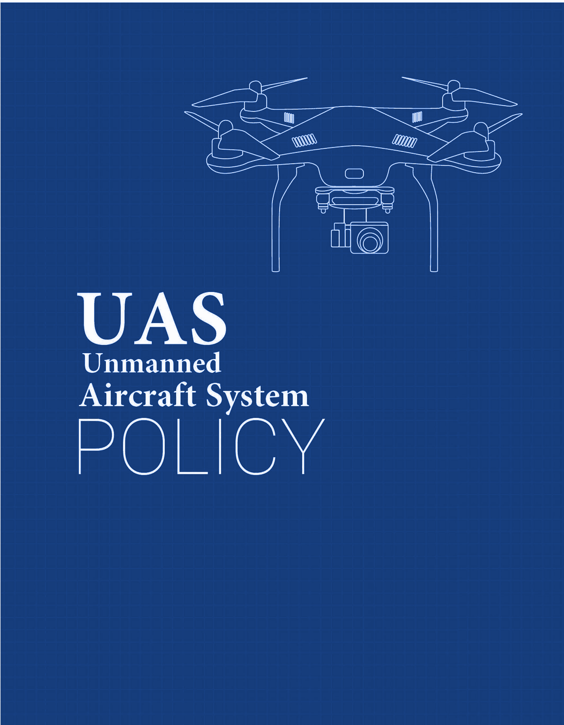

Airport Name

[Airport Name] UAS Policy

Table of Contents

**Policy** **2**

Purpose 2

Authority 2

Scope 2

**Definitions** **3**

**Operating Procedures** **4**

Procedure for Flight approval 4

Classification of Use 4

UAS Registration Requirement 5

Employee UAS Operation 5

Contractor UAS Operation 5

Payload Authorization 6

Prohibited UAS Use 6

**Pre-Flight/Post-Flight** **6**

**Sanctions** **9**

**Resources** **9**

**Frequently Asked Questions** **9**

## 

## Policy

### Purpose

The purpose of this Unmanned Aircraft System (UAS) Policy is to establish scope and governance of Unmanned Aircraft Systems (UAS) activities for [Airport Name] business and the use of UAS on or over Airport property. It also serves to establish the Designated UAS Authority responsible for overseeing UAS activities at [Airport Name].

This policy requires that all [Airport Name] sponsored UAS operations taking place on airport grounds, will be conducted in a manner ensuring individual privacy and safety, in accordance with all applicable Federal, State, and Local laws.

### Authority

[Designated UAS Authority] department is responsible for approving any UAS on or over [Airport Name] terminal.

Contacts:

Department_______________

UAS Team Coordinator_______________

Phone number_______________

Email_______________

### Scope

This policy is applicable to:

* + 1. Airport staff and third-party contract workers operating UAS on airport property.
    2. All platforms of UAS which include, but are not limited to: sUAS, UAV, Drone, Model Aircraft, regardless of size or weight.
    3. Any individuals who operate UAS on [Airport Name] property, including persons not affiliated with the Airport.
    4. Any individuals operating UAS purchased with funding through the

Airport, including Airport accounts, grants, or foundation accounts.

## Definitions

**Federal Aviation Administration (FAA)** – A division of the Department of Transportation that inspects and rates civilian aircraft and pilots, enforces the rules of air safety, and installs and maintains air-navigation and traffic-control facilities.

**Unmanned Aircraft System (UAS)** – An unmanned aircraft system, sometimes called a drone, is an aircraft without a human pilot onboard – instead, the drone is controlled from an operator on the ground. Sometimes prefaced as a Small Unmanned Aircraft System (sUAS).

**Unmanned Aerial Vehicle (UAV)** - An unmanned aerial vehicle is a powered, aerial vehicle that does not carry a human operator, uses aerodynamic forces to provide vehicle lift, can fly autonomously or be piloted remotely.

**Drone** - The common term for UAV, UAS, and sUAS.

**Remote Pilot-in-Command (RPIC)** - The official term given by the FAA for the individual who either directly operates the UAS or directly supervises another individual operating the UAS. The Remote Pilot in Command must have the proper FAA UAS pilot certifications and abide by the necessary FAA regulations and this policy.

**Designated UAS Authority** – The individual, department, or committee designated by the [Airport Name] as authorized to provide oversight for UAS activities.

## Operating Procedures

### Procedure for Flight approval

Regardless of flight purpose, anyone intending to fly a UAS at [Airport Name] property or sponsored activity/event must submit an application to the [UAS Department Name].

Application must include:

* Photo ID
* Proof of FAA registration
* Picture of UAV with owner information included
* FAA permit is required
* Picture of UAV with owner information included
* Copy of Part 107 licenses (Commercial use only)
* Copy of vendor insurance (Commercial use only)
* Safety plan

Application review: [Designated UAS Authority] will review the application, request additional information to either approve or deny. [Designated UAS Authority] reserves the right to cancel or reschedule any approved UAS usage.

Approval: Upon approval, the applicant will be issued a UAS use permit, authorizing the use of UAS as outlined in the permit. The pilot must keep a physical copy of the UAS permit on him/her while operating the UAS. The [Designated UAS Authority] will approve only the necessary duration for the proposed activity. Recurring flight approvals may be requested.

### Classification of Use

* Employee Operation: In-house business operations of a UAS is permitted on airport property. It will require approval from the [Airport Name] UAS department.
* Contractor Operation: Commercial UAS operations and 3rd party vendors are permitted after application approval from [UAS Committee] department. [Airport Name] employees can request approval for contractor UAS operations.

### UAS Registration Requirement

* UAS that weigh in excess of 0.55 Lbs. must be registered with the FAA before an application is submitted. Proof of registration must be submitted with the application.
* UAS registration number and owner contact information must be listed on the UAV
* Non-US Citizens who are not eligible to register a UAS in the united states must follow the FAA guidelines.

### Employee UAS Operation

Employees operating UAS on behalf of [Airport Name] must adhere to the following:

1. Obtain approval from [Airport] UAS department
2. Hold a valid FAA remote pilot certification or be under the direct supervision of a person who does hold a remote pilot certificate
3. Ensure that their UAS is registered and insured
4. Complete any required [Airport] UAS training

### Contractor UAS Operation

Third-party contractors operating UAS on behalf of [Airport Name] must adhere to the following:

1. The [Airport Name] UAS coordinator is responsible for coordinating the work of contractors who will be utilizing UASs on [Airport’s] behalf is responsible for providing that contractor with a copy of this policy.
2. All Commercial UAS operations must be conducted by a certified remote Pilot with a Part 107.
3. The contractor must agree to abide by the FAA Part 107 regulations – or the contractor’s Section 333 Exemption – and related policy points within this document.
4. The airport must also check the FAA guidelines and zones before flying and obtain a proper exemption if the flight-area is in a no-fly zone.
5. Contractors/third-party operators must provide a copy of their insurance coverage when submitting the application.
6. The contractor must agree, as a part of its contract, to indemnify and hold [Airport Name] harmless from any liability stemming from personal injury or property damage arising from the contractor’s UAS operations.
7. The contractor must further agree to procure adequate insurance of $____ million to protect against such liability and provide [Airport] with a certificate of insurance showing [Airport’s] additional insured status.

### Payload Authorization

The person requesting authorization to operate a UAS, must clearly identify the payload function, size and weight. Access points or any devices that might interfere with the campus network are prohibited.

### Prohibited UAS Use

* UAS operation is prohibited if any person(s) acting as a UAS pilot:
* Consumed alcohol in the past 12 hours
* Have used any drugs that affect the person’s faculties in any way.
* Operated without a permit
* For recreational use

## Pre-Flight/Post-Flight

Pre-Flight Checklists and Mission Logs must be conducted for each UAS mission by the [Airport Name] or by a third-party for the [Airport Name]. If more than one drone is flown during the same mission, each drone and its flight details must be recorded on the Mission Log report. Below are examples of a Pre-Flight Checklist and a UAS Flight Mission Log.

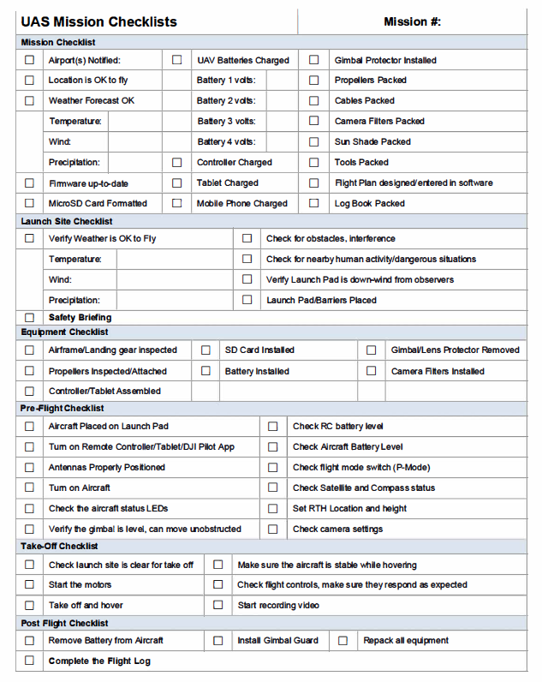

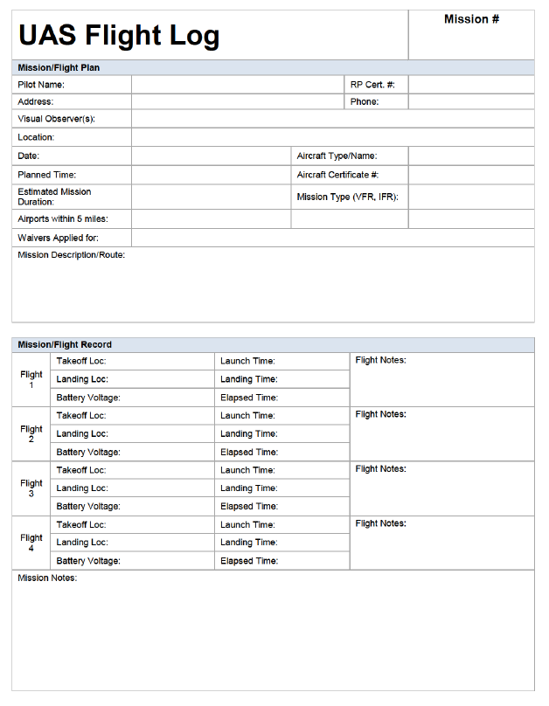

## Sanctions

Any violations of university policies by an individual will be dealt with in accordance with applicable university policies and procedures, which may include disciplinary actions up to and including termination from the university.

Fines or damages incurred by individuals or units that do not comply with this policy will not be paid by [University Name] and will be the responsibility of those persons involved.

## Resources

FAA’s general page for Unmanned Aircraft Systems information: <https://www.faa.gov/uas/>

FAA B4UFly Mobile App

<https://www.faa.gov/uas/where_to_fly/b4ufly/>

FAA Certificate of Waiver or Authorization (COA)

<https://www.faa.gov/about/office_org/headquarters_offices/ato/service_units/systemops/aaim/organizations/uas/coa/>

FAA Summary of Small Unmanned Aircraft Rule (Part 107): <https://www.faa.gov/uas/media/Part_107_Summary.pdf>

FAA’s Becoming a Pilot:

<https://www.faa.gov/uas/getting_started/part_107/remote_pilot_cert/>

FAA’s Sample Preflight Inspection Checklist: [https://www.faasafety.gov/files/gslac/courses/content/451/1458/Preflight%20Inspection%20 Checklist.pdf](https://www.faasafety.gov/files/gslac/courses/content/451/1458/Preflight%20Inspection%20)

Know Before You Fly

<http://knowbeforeyoufly.org/>

U.S. DHS Best Practices for Protecting Privacy, Civil Rights & Civil Liberties In UAS Programs:

<https://www.dhs.gov/sites/default/files/publications/UAS%20Best%20Practices.pdf>

## Frequently Asked Questions

You may want to consider answering some Frequently Asked Questions, to help inform and educate your public civilians, employees, and any third-party operators on the use of drones in your community.

FAA Frequently Asked Questions: <https://www.faa.gov/uas/faqs/>

Created by:



**Solutions to Secure Your Airspace**

[**www.911security.com**](http://www.911security.com/)